FOR IMMEDIATE RELEASE

April 8, 2024

Contact: Lauren Jurgemeyer, Publicity Coordinator
Phone: 512-245-1543
Email: theatre@txstate.edu

Bobcat Promotions to collaborate with Texas State’s theatre department to form ‘Moon Street Media’

SAN MARCOS, Texas — Bobcat Promotions (BPR), a student-run media strategies firm, is launching Moon Street Media in conjunction with the theatre department; this team will produce content promoting theatre at Texas State University.

The collaboration piloted with “When Thou Wakest,” a Shakespearean production adapted by faculty member Nick Lawson, that ran in the Studio Theatre March 5-8. Beginning During the subsequent play “Small Mouth Sounds” by Bess Wohl, the team introduced an “Exclusive First Look” series using photos taken by a BPR member.

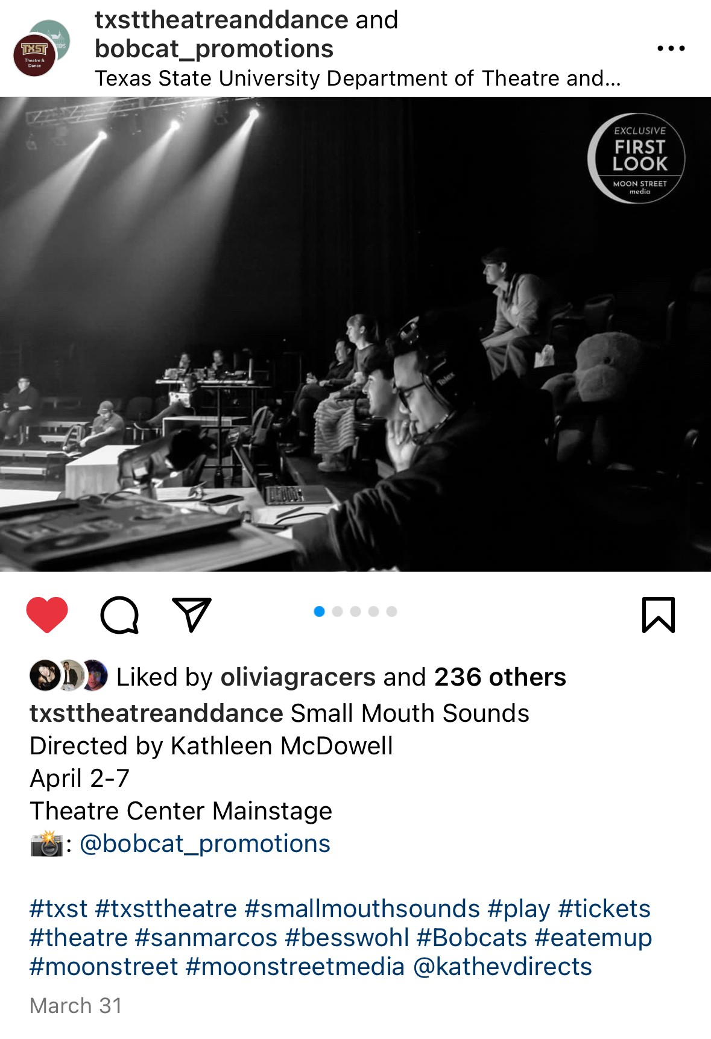
Image of Moon Street Media’s “Exclusive First Look” Instagram post https://www.instagram.com/p/C5MHTnRJYxe/?utm_source=ig_web_copy_link

The partnership has been well-received by the theatre department’s senior leadership. Lauren Jurgemeyer, Publicity Coordinator of the theatre department, welcomed the initiative. Coincidentally, she graduated from Texas State with a B.S. in Digital Media Innovation and was the Web Content Manager at KTSW.

“As an alumna from the School of Journalism and Mass Comm, I am thrilled to support this endeavor,” Jurgemeyer said. “This was something that I would have loved to be involved in as a student, I tried to do it on a smaller scale with just written articles and photography of theatre shows, but this has the potential to be so much bigger and more fulfilling. As this effort grows, I hope it sets our university apart from other schools and showcases our multi-talented students for years to come.”

Moving forward, Moon Street Media will expand to promoting all of the department’s productions and programs, as well as its faculty and students, in addition to continuing the “Exclusive First Look” series on social media, writing reviews of productions and doing interviews with the production team.

Lauren Magee, Director of Moon Street Media, a BPR staff member and acting and public relations double major, worked to implement the concept.

“This effort has created a wonderful opportunity for Mass Comm students to get hands-on experience, while also helping to highlight the aspects of theatre and our department that can be overlooked,” Magee said. “Moon Street Media combines my two passions, and I am so grateful to be a part of its launch! I think this is a win-win for both groups.”

Promotional content will first appear on the respective Instagrams, @txsttheatreanddance and @bobcat_promotions, as well as the Moon Street Media tab on the BPR website, and the theatre department’s newsletter.

Chuck Kaufman, BPR adviser, said he was impressed by the enthusiasm shown by students who attended and raved about Magee’s recent performance as the lead in “Three Sisters.”

“Their glowing reviews of the production and personal enthusiasm for Lauren convinced me that such promotions need our help and give us some new opportunities in the arts," Kaufman said. “We can meet that need.”

To get involved with Moon Street Media or join BPR, please email Charles Kaufman at ck17@txstate.edu. To purchase tickets for the theatre department’s upcoming productions, please visit https://txstatepresents.universitytickets.com/.

###

Moon Street Media is a collaboration between Bobcat Promotions and Texas State University’s Department of Theatre and Dance, promoting season productions, degree programs, in addition to accomplished students, alums, and faculty members. Its namesake is the street on which both university theatre facilities reside — Moon Street. Founded in 2024, Moon Street Media is committed to highlighting the university’s excellent theatrical work and achievements. For more information, please visit https://bobcatpromotions.com/moon-street-media/.

